W**EEKLY PROGRESS REPORT**

BY ANURAG SINGH

MUSIC PLAYER APP

* DATE:22/7/23
* PROJECT OVERVIEW:

The goal of this project is to develop a music player app for android that allows users to play audio files, create playlists, manage their music library, and provide a smooth and intuitive user experience.

* Accomplishments this Week:

1. Understanding the project objectives.
2. Understanding the app's core features and functionality, including audio playback, playlist creation, and library management.
3. Implementation of intent that will help the music player to make it multiscreen app.
4. Learning about the Scroll View (Horizontal and Vertical) that will help in enhancement of the interface view .
5. Implementing another seekbar of music duration that synchronized with music.
6. Fixing up the volume Seek Bar.
7. Implementing of Image insertion in horizontal view layout that will provide flexibility to add more images.

* Coding the intent part to set up Multiscreen in app

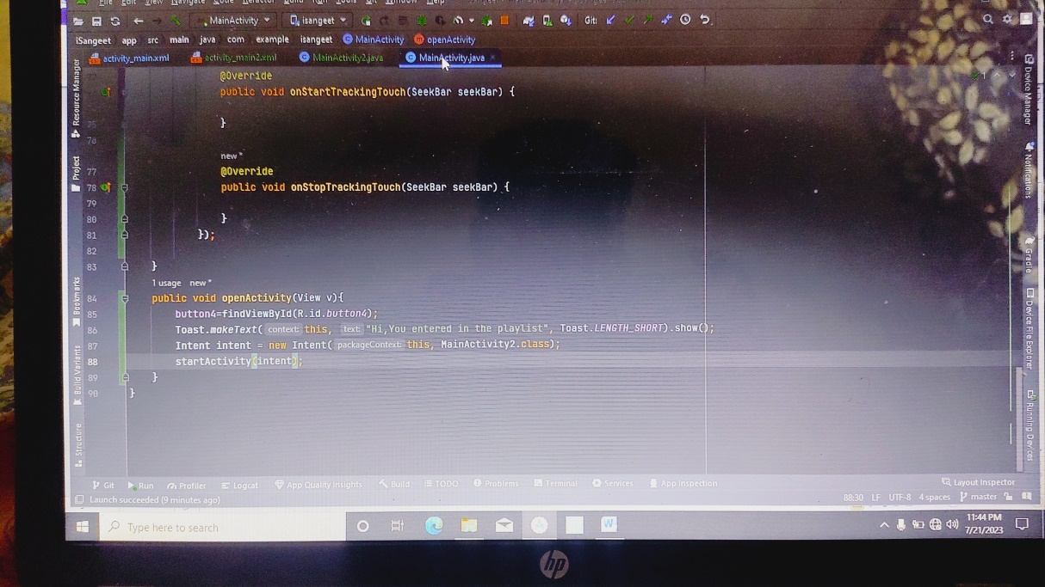

* 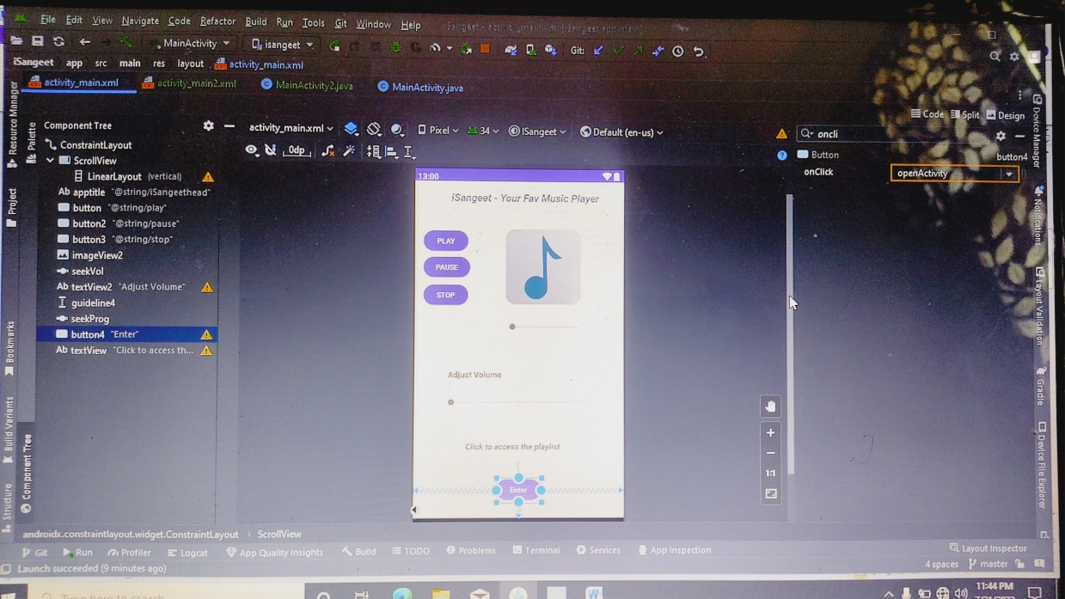
* **Setting up the scrollview in mainActivity 2 playlist section**

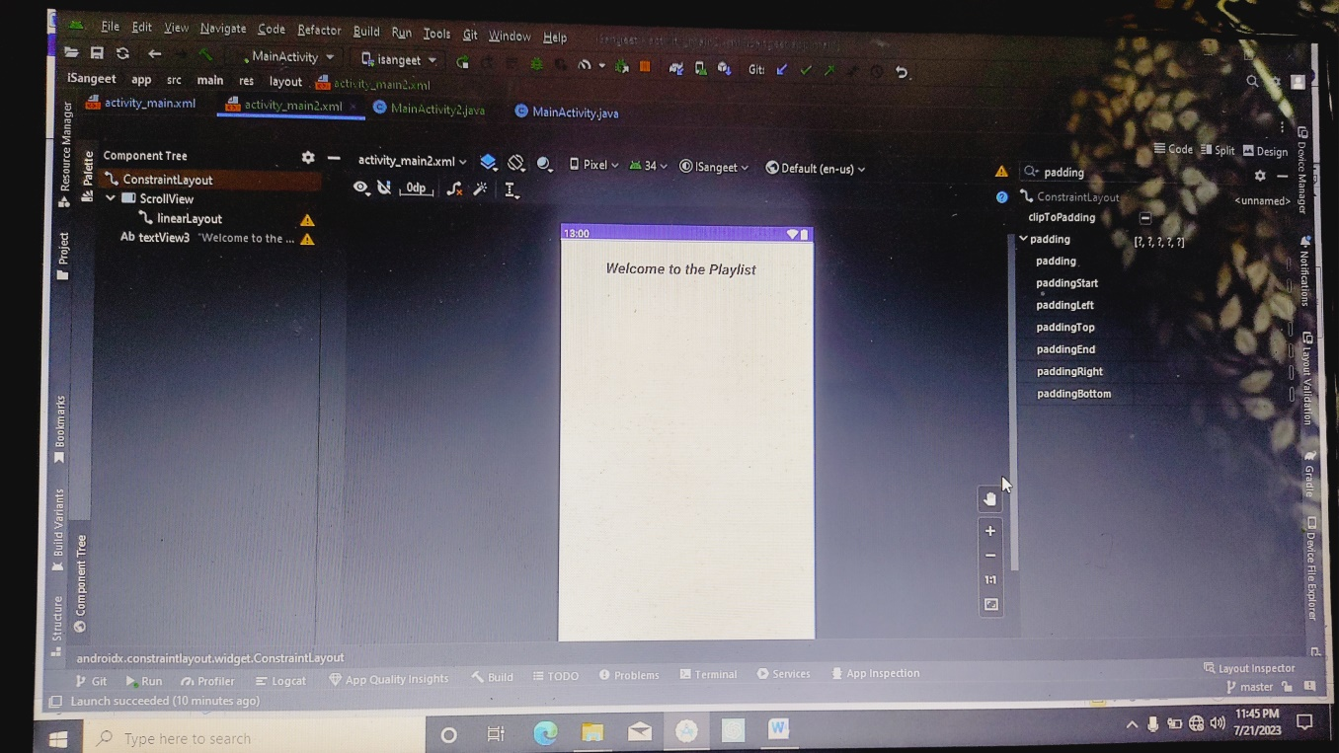

* **Setting up the Seekbar in music player**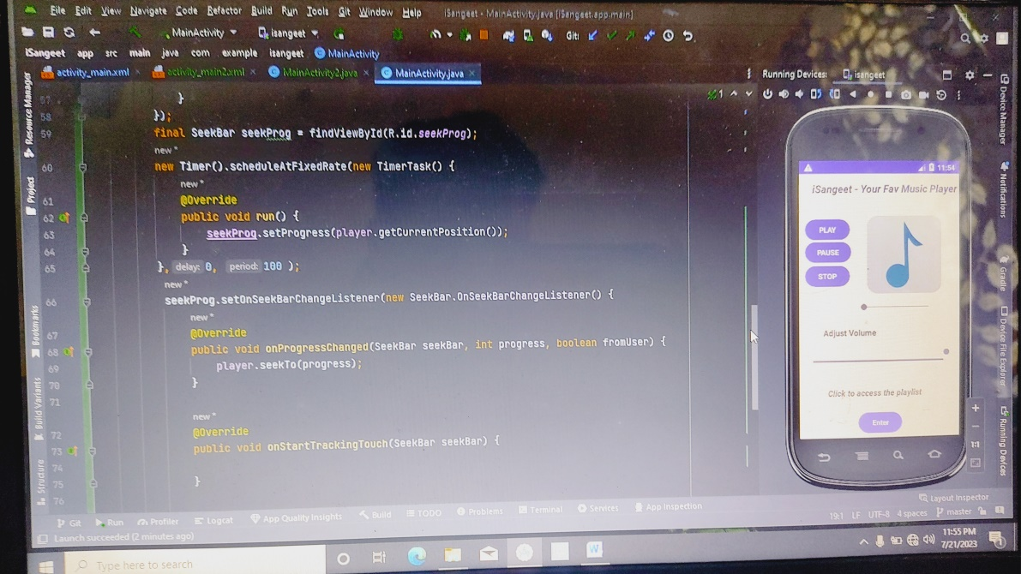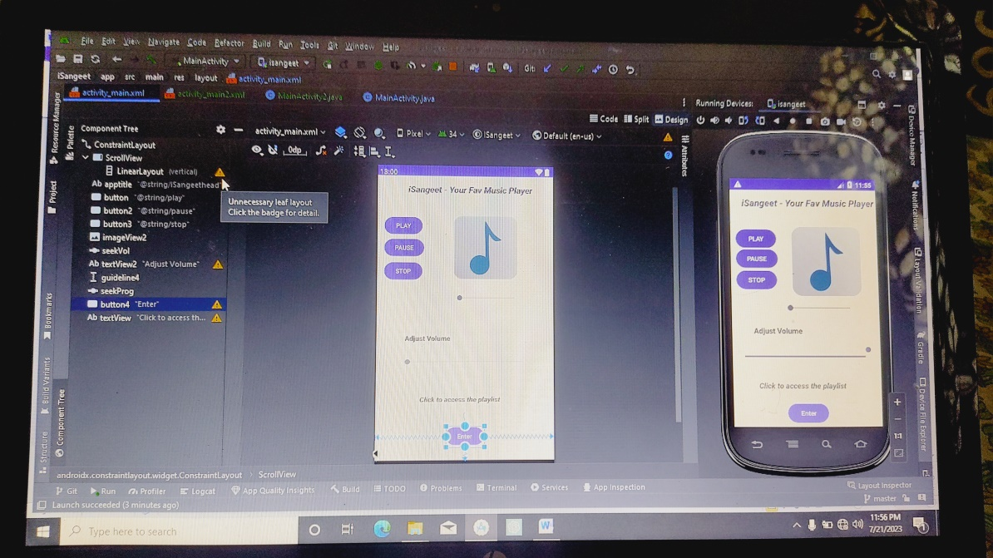
* **Challenges Faced:**

1. Faced while learning and implementing of intent in isangeet app.
2. Setting up the Seekbar and removing bug.

* **Next Week Objective:**

1. Database Management in isangeet app.
2. Provide functionality to efficient web music.
3. Implementing functionality to its second screen interface.

Git hub link - [anuragsingh-003/iSangeet (github.com)](https://github.com/anuragsingh-003/iSangeet)